Laboratory Session 1 Experiment 1: Newton’s 2nd Law of Motion

# OBJECTIVE:

The objective of this experiment is to investigate Newton’s Second Law of Motion, which states:

*The vector sum of all the forces acting on an object of constant mass is* equal *to the product of the object’s mass and its acceleration,*

∑ $\vec{F}$ = $m\vec{a}$ 𝐸𝑞𝑛. 1

*Where the units of F, m and a are N, Kg and m.s-2* respectively. *The* acceleration $\vec{a}$*has the same direction as the resultant force* ∑ 𝐹⃗*.*

# HYPOTHESIS:

The acceleration of a vehicle can be accurately modelled using Newton’s Second Law of Motion.

# APPARATUS

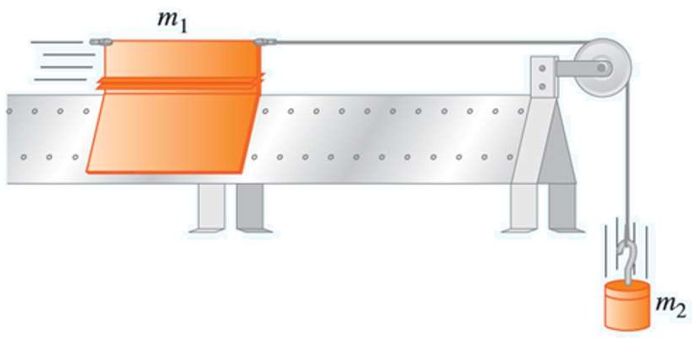

**Figure 1a**

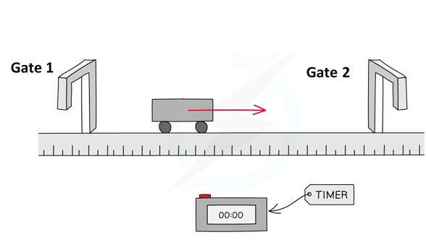

**Figure 1b**

**L**

**Figure 1.** Setup of the equipment

|  |  |
| --- | --- |
| * Air blower | * Digital timer |
| * Air track | * + Weights |
| * Vehicle | * + String |
| * Light gates | * Electronic balance |

**INSTRUCTIONS:**

1. Measure the mass of the vehicle, 𝑚1, and length of the vehicle, *L.*Record the value in Table 1.
2. Measure the mass of the hanger that will contain the different masses used to accelerate the vehicle and record this value in the measured mass *m2* column of Table 3, i.e. it is measurement no. 1.
3. Assemble the apparatus as shown in Figure 1a without the second mass, 𝑚2. Switch on the air blower, and carefully level the track so that a vehicle positioned midway along it exhibits little or no tendency to move. **Do NOT keep switching the air blower on and off!**
4. Attach the mass hanger to the vehicle as shown in Figure 1a.

**N.B. DO NOT pull the vehicle through the gates after each measurement.** Rather, lift the vehicle over the gates and position it slightly before Gate 1, before taking each measurement.

1. Ensure that the light gates are positioned appropriately on the track, so that the vehicle will still be experiencing a constant accelerating force when the vehicle passes through this gate (i.e. make sure the small mass, 𝑚2, does not hit the floor before the vehicle passes through gate 2).
2. To make the digital timer used in this part of the experiment operational, carry out the following:
3. Ensure that the digital timer used in this part of the experiment is properly connected to the light gates by verifying the following signals:

|  |  |
| --- | --- |
| Signals | Notation |
| **-1-2** | **Both gates are connected** |
| -1- - | Only the 1st gate is connected |
| - -2- | Only the 2nd gate is connected |

1. Next press the “mode” button until it shows P3 (N.B. P3 is the mode of acceleration measurement).
2. Immediately turn on the air blower with holding the vehicle on the track.
3. Then press “start” button to start digital timer and immediately release the vehicle.
4. Read the time $t_{1}$, $t_{2}$ and $t_{3}$ in millisecond (ms) and convert them to second (s) to fill in Table 2.1 The 1st Measurement.
5. Then use the following equation to calculate the corresponding velocity when the vehicle passing through gate 1, $v_{1}$ and velocity when the vehicle passing through gate 2, $v_{2}$. Fill the velocity in Table 2.1.

$v_{1}=\frac{L}{t_{1}}$ 𝐸𝑞𝑛. 1

$v_{2}=\frac{L}{t_{3}}$ 𝐸𝑞𝑛. 2

where $L$ is the length of the vehicle (m);

$t_{1}$ is the time when the vehicle goes through Gate 1 (s);

$t_{3}$ is the time when the light gate goes through Gate 2 (s).

1. Repeat these measurement 3 times and calculate the acceleration $a$ by the following equation. The measurement of time with the same mass of the weights should be repeated for 3 times and notated as $a_{1}$, $a_{2}$ and $a_{3}$ filling in Table 2.1.

$a =\frac{v_{2}-v_{1}}{t_{2}}$ 𝐸𝑞𝑛. 3

where $t_{2}$ is the time taken for vehicle to go between Gate 1 to Gate 2 (s);

$a$ is the acceleration of the vehicles (m.s-1).

1. Copy , and $a_{3}$ from Table 2.1 to Table 3: Measurement 1. Calculate the measured acceleration by taking the average of these 3 acceleration values $a_{1}$, $a_{2}$ and $a_{3}$ and record the value in Table 3.
2. Calculate the mass ratio $\frac{m_{2}}{m_{1}+m_{2}}$, and record the value in Table 3: Measurement 1.
3. Calculate the predicted acceleration, 𝑎p, and record the value in Table 3: Measurement 1. (N.B. this part can be done after the lab.)
4. Repeat steps 6 to 9 an additional 4 times by filling Table 2.2 to Table 2.5, each time you should increase the mass on the hangar by adding an additional 10 g mass. Then record the measurements and calculate predicted acceleration in Table 3.

The following part can be done after the class:

1. Use the “Uncertainty Guide: Laboratory Session 1” from Moodle to complete Tables 4 and 5. This can be done after the lab session.
2. Using Microsoft Excel, plot a suitable graph to depict the key information in Tables 3 and 5. Use the “Report Writing” videos and the “Producing a Good Graph” PowerPoint Presentation on the Foundation physics Moodle page to help you.

**MEASUREMENTS & CALCULATIONS:**

**Table 1: Mass (m1) and length (L1) of the vehicle**

|  |  |
| --- | --- |
| m1 (g) | L (m) |
|  |  |

**Measured acceleration**

**Table 2.1 The 1st Measurement - m1**

|  |  |  |  |  |  |  |
| --- | --- | --- | --- | --- | --- | --- |
| Measurement No. | measured time  (s) | | | measured velocity (m.s-1) | | measured acceleration (m.s-2) |
| **t1** | **t2** | **t3** | **v1** | **v2** |  |
| 1 |  |  |  |  |  |  |
| 2 |  |  |  |  |  |  |
| 3 |  |  |  |  |  |  |

**Table 2.2 The 2nd Measurement - m2**

|  |  |  |  |  |  |  |
| --- | --- | --- | --- | --- | --- | --- |
| Measurement No. | measured time  (s) | | | measured velocity (m.s-1) | | measured acceleration (m.s-2) |
| **t1** | **t2** | **t3** | **v1** | **v2** |  |
| 1 |  |  |  |  |  |  |
| 2 |  |  |  |  |  |  |
| 3 |  |  |  |  |  |  |

**Table 2.3 The 3rd Measurement - m3**

|  |  |  |  |  |  |  |
| --- | --- | --- | --- | --- | --- | --- |
| Measurement No. | measured time  (s) | | | measured velocity (m.s-1) | | measured acceleration (m.s-2) |
| **t1** | **t2** | **t3** | **v1** | **v2** |  |
| 1 |  |  |  |  |  |  |
| 2 |  |  |  |  |  |  |
| 3 |  |  |  |  |  |  |

**Table 2.4 The 4th Measurement - m4**

|  |  |  |  |  |  |  |
| --- | --- | --- | --- | --- | --- | --- |
| Measurement No. | measured time  (s) | | | measured velocity (m.s-1) | | measured acceleration (m.s-2) |
| **t1** | **t2** | **t3** | **v1** | **v2** |  |
| 1 |  |  |  |  |  |  |
| 2 |  |  |  |  |  |  |
| 3 |  |  |  |  |  |  |

**Table 2.5 The 5th Measurement - m5**

|  |  |  |  |  |  |  |
| --- | --- | --- | --- | --- | --- | --- |
| Measurement No. | measured time  (s) | | | measured velocity (m.s-1) | | measured acceleration (m.s-2) |
| **t1** | **t2** | **t3** | **v1** | **v2** |  |
| 1 |  |  |  |  |  |  |
| 2 |  |  |  |  |  |  |
| 3 |  |  |  |  |  |  |

**Table 3. Measurements and predicted value**

|  |  |  |  |  |  |  |  |
| --- | --- | --- | --- | --- | --- | --- | --- |
| Measurement No. | m2  (g) |  | measured  acceleration  (m.s-2) | | | | predicted  acceleration  (m.s-2) |
| **a1** | **a2** | **a3** | **am** | **ap** |
| 1 |  |  |  |  |  |  |  |
| 2 |  |  |  |  |  |  |  |
| 3 |  |  |  |  |  |  |  |
| 4 |  |  |  |  |  |  |  |
| 5 |  |  |  |  |  |  |  |

**UNCERTAINTY ANALYSIS:**

**Table 4: Uncertainty on mass of the vehicle**

|  |
| --- |
| δm1(g) |
|  |

**Table 5. Uncertainties associated with measured and predicted values**

|  |  |  |  |  |
| --- | --- | --- | --- | --- |
| Measurement No. | $δm_{2}$ (g) | **δ $\frac{m_{2}}{m_{1}+m_{2}}$** | $$δa_{m}$$ | $$δa_{p}$$ |
| 1 |  |  |  |  |
| 2 |  |  |  |  |
| 3 |  |  |  |  |
| 4 |  |  |  |  |
| 5 |  |  |  |  |

### **Laboratory Session 1**

### **Experiment 2: Period of Oscillation Versus Angular Amplitude**

### **OBJECTIVE:**

The objective of this part of the experiment is to investigate the relationship between the period of oscillation of an oscillating pendulum and the pendulum’s angular amplitude.

### **HYPOTHESIS:**

Changing the angular amplitude will have no effect on the period of oscillation of the pendulum.

**APPARATUS**

|  |  |  |
| --- | --- | --- |
|  | * Pendulum bob * String * Test frame * Stopwatch * Ruler | |
| **Figure 2.1.** The Pendulum Bob and Test Frame. | |

**INSTRUCTIONS:**

1. Using the apparatus in Figure 2.1, set the length of the pendulum, *L*, to be 65 cm. This will remain **constant throughout this part of the experiment.**
2. Start the pendulum bob swinging through an angular amplitude of 0.1 radians (approximately 6°). The angular amplitude is represented by θ in Figure 2.2, and the associated displacement (*x*) from the equilibrium position is referred to as the amplitude of the pendulum.

|  |
| --- |
| **Figure 2.2** An idealised simple pendulum. |

To ensure that the pendulum oscillates at an angular amplitude of 0.1 radians, you will need to use a protractor.

1. Measure the time for the pendulum bob to complete 10 oscillations/periods, then calculate the corresponding average time for 1 oscillation/period, record these values in Table 2.1.
2. Repeat step 3 for different measurements of the angular amplitude, as shown in Table 2.1.
3. Calculate the predicted time period for the pendulum for each angular amplitude and record these values in Table 2.1.
4. Use the “Uncertainty Guide: Lab Session 1” file available on Moodle to complete Table 2.2.
5. Use Microsoft Excel to plot a suitable graph to depict the key information in Tables 2.1 and 2.2.

**MEASUREMENTS & CALCULATIONS:**

**Table 2.1.** Measured and predicted period.

|  |  |  |  |  |
| --- | --- | --- | --- | --- |
| **Measurement no.** | **Angular amplitude $ϕ$**  **(radians)** | **Time period for 10 oscillations $10T$ $(s)$** | **Average time for 1 oscillation $T_{m}$ $$(s)$$** | **Predicted period $T_{p}$ $$(s)$$** |
| 1 | **0.1** |  |  |  |
| 2 | **0.2** |  |  |  |
| 3 | **0.3** |  |  |  |
| 4 | **0.4** |  |  |  |

**UNCERTAINTY ANALYSIS:**

**Table 2.2.** Uncertainties associated with measured and predicted values for

|  |  |  |  |  |
| --- | --- | --- | --- | --- |
| **Measurement no.** | **δ $ϕ$**  **(radians)** | **δ10*T***  **(s)** | **δ*T***  **(s)** | **δ*T*p**  **(s)** |
| 1 |  |  |  |  |
| 2 |  |  |  |  |
| 3 |  |  |  |  |
| 4 |  |  |  |  |

### **Laboratory Session 1**

### **Experiment 3: Period of Oscillation Versus Pendulum Length**

### **OBJECTIVE:**

The objective of this part of the experiment is to investigate the relationship between the period of oscillation of a pendulum and its length.

### **HYPOTHESIS:**

The relationship between a pendulums length and time period can be accurately modelled using Christiaan Huygens's law;

$T=2π\sqrt{\frac{l}{g}}$ $Eqn. 3.1$

### **APPARATUS & INSTRUCTIONS:**

|  |  |  |
| --- | --- | --- |
|  | * Pendulum bob * String * Test frame * Stopwatch * Ruler | |
| **Figure 3.1.** The Pendulum Bob and Test Frame. | |

1. Using the apparatus in Figure 3.1, set the length of the pendulum to 65 cm and record this value as measurement 1 in Table 3.1.
2. Start the pendulum bob swinging through an angular amplitude of 0.1 radians (approximately 6°). The angular amplitude is represented by θ in Figure 3.2, and the associated displacement (*x*) from the equilibrium position is referred to as the amplitude of the pendulum.

|  |
| --- |
| **Figure 3.2.** An idealised simple pendulum. |

1. Measure the time for the pendulum bob to complete 10 oscillations/periods, then calculate the corresponding average time for 1 oscillation/period, record these values in Table 3.1.
2. Repeat step 3 for different lengths of the pendulum. You should reduce the length of the pendulum by **approximately 2.5 cm** for each new measurement.
3. Calculate the predicted time period for the pendulum for each value of length and record these values in table 3.1.
4. Use the “Uncertainty Guide: Lab Session 1” file available on Moodle to complete Table 3.2.
5. Use Microsoft Excel to plot a suitable graph to depict the key information in Tables 3.1 and 3.2.

**MEASUREMENTS & CALCULATIONS:**

**Table 3.1.** Measured and predicted period.

|  |  |  |  |  |
| --- | --- | --- | --- | --- |
| **Measurement no.** | **Measured length L**  **(m)** | **Measured time for 10 oscillations 10T (s)** | **Average time for 1 oscillation T**  **(s)** | **Predicted period Tp**  **(s)** |
| 1 |  |  |  |  |
| 2 |  |  |  |  |
| 3 |  |  |  |  |
| 4 |  |  |  |  |
| 5 |  |  |  |  |
| 6 |  |  |  |  |
| 7 |  |  |  |  |
| 8 |  |  |  |  |

**UNCERTAINTY ANALYSIS:**

**Table 3.2.** Uncertainties associated with measured and predicted values

|  |  |  |  |  |
| --- | --- | --- | --- | --- |
| **Measurement no.** | **Standard uncertainty δL**  **(m)** | **Standard uncertainty δ10*T***  **(s)** | **Standard uncertainty δ*T***  **(s)** | **Standard uncertainty δ*T*p**  **(s)** |
| 1 |  |  |  |  |
| 2 |  |  |  |  |
| 3 |  |  |  |  |
| 4 |  |  |  |  |
| 5 |  |  |  |  |
| 6 |  |  |  |  |
| 7 |  |  |  |  |
| 8 |  |  |  |  |